„Living in Process“- Intensive and Hiking week

A week for people who are in the Training and
those, who want to learn more about the Training!

11. - 18. July 2026
Foischinghof in Oberau / Wildschönau – Tyrol
Schönbergweg 59, 6311 Wildschönau
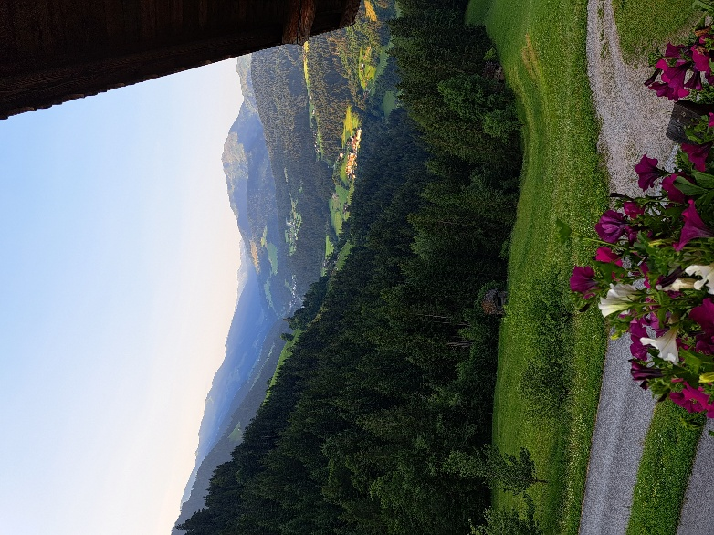

Nothing can inspire like nature.
One of the easiest ways to return
to mental health is to
let nature put us in our place.

Anne Wilson - Schaef

We, the Austrian „Living in Process” Regional Group, are delighted to be able to offer another hiking week in July 2026.
Living in community and connection with everything and everyone. We hike, play, and cook together; we sit in group and share our experiences; we take time for our feelings on the “mat”; there will also be 12-step meetings to help us deal with our addictions and dependencies.

Location:
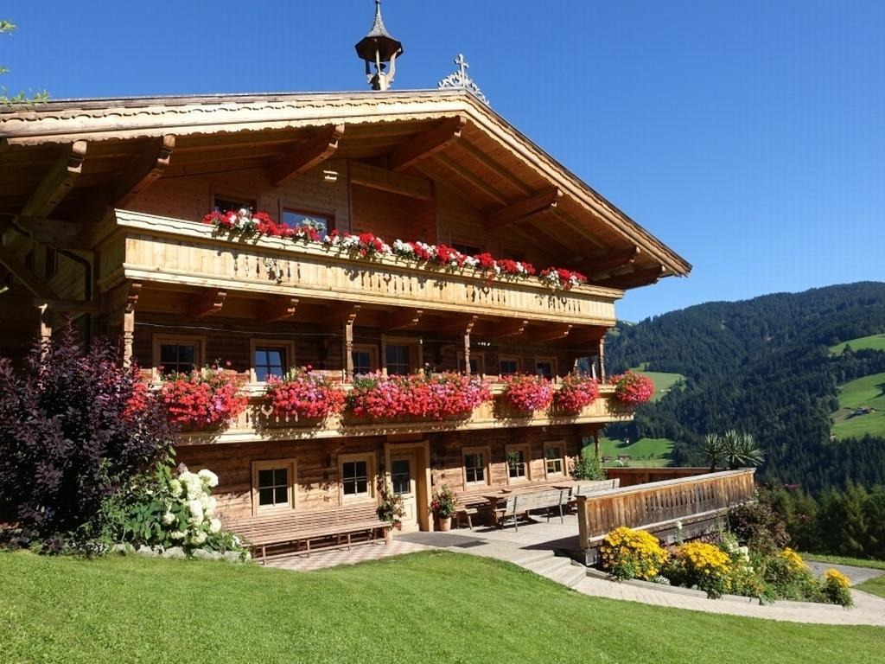
For this we have found a very well suited house in a beautiful environment, the Foischinghof in the Wildschönau – in the district Oberau.
www.foischinghof.at
It is located at 1000 m above sea-level and offers a fantastic view of the Kitzbühel Alps with many hiking trails starting right outside the door.
Martina and Gottfried Klingler run the farm as an organic farm and welcome their guests with great friendliness and openness.

Type of accomodation:

The house is self-catering and offers us a very well equipped kitchen. A large dining and recreation room is also available for our use.
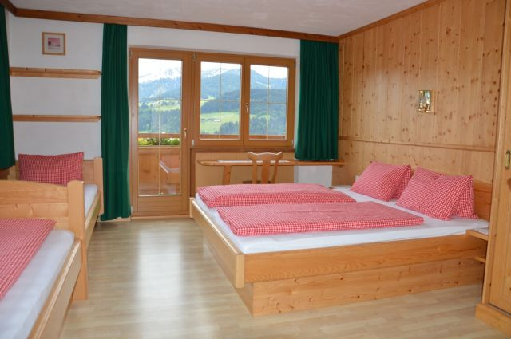
The cozy bedrooms all have a sink; shower rooms and toilets are located in the hallways.
The house would accomodate 46 people. As we want to limit the group to a total of 25 people, we will have plenty of space and freedom of movement: there are 9 four-bed rooms, 2 rooms with 3 beds and 2 double bed rooms.

We will also have a large, bright group room (size of a barn). In addition, one side of this room can be opened almost completely with a sliding door, so that you feel like you are outdoors yet still protected.

Although the house is built on a slope, there is also a wonderful playground for badmington and much more.

Beginning and end:

Arrival is possible on Saturday, 11th July at earliest 5 pm.
Beginning: Saturday, 7 pm, with a simple dinner for all.
Departure: Saturday, 18th July, after breakfast and cleaning up together.

Fees:

Intensive: 425 €

Accomodation: 265 € (for the entire week)

This amount consists of: 31,50 € per day for the over-night stay; 3,50 € per day tourism tax (we will receive a guest card, which offers free entrance to the swimming pool); 10 € contribution to the final clean-up and 10 € for the rental of bed linen. If you bring your own bed linen (covers) the total amount diminishes to 255 € for the week.

Cost of food (self-catering): 150 € (final settlement at the end of the week)

Payment terms: 425 € at registration
415 € (or 405 € without bed linen) until registration deadline

Registration deadline is the 13th June 2026

Cancellation policy:

- Cancellation bevor the registration deadline: we keep an administration fee of 30 €.
- Cancellation after the registration deadline: the entire fee for the intensive, 425 €, must be payed, unless another participant is found in replacement.
- Cancellation from 1st July 2026 onwards: the accommodation (without tourism tax) must be payed in addition (220,50 €), unless another participant is found in replacement.

Registration and questions to:

Gerhard Starcevic  Friedensring 22  A – 2120 Obersdorf  Tel.:0043 680 4426230  Email: gstaci27@gmail.com | Or: | Traude Schmid  Sulzbach 29  A – 3184 Türnitz  Tel: 0043 677 62186960  Email: naraf@aon.at

Bank details:

Beatrix Amon
IBAN: AT05 3250 1000 0002 9983

With the down-payment of 425 € your registration is binding.

Travel information:

The journey via Wörgl in Tyrol is easy as well for people arriving by car or by bus. Directly in front of the train station Wörgl you can take the bus (770), 35 minutes later you arrive at destination Oberau.
The exit station is called “Dorferwirt”; we will be picking up participants from there by car.

People traveling by car should also look out for this “Dorferwirt” (an Inn – immediately after an “eni” petrol station), you need to turn right just after this Inn: a green sign with “Lenzen – Egg” written on it points to the right. Shortly afterward you have to decide again: here please follow the road towards Egg – approximately 2 km uphill, then you can’t miss the Foischinghof any longer: it is the bigger one of two houses.

Registration:

I hereby register bindingly for the hiking week at the Foischinghof in Wildschönau from July 11th to 18th, 2026.

Name:

Address:

Phone:

Mail:

At the same time I transferred the down payment of 425 € into the account of Beatrix Amon. Until the registration deadline on 13th June 2026 I shall transfer the remaining 415 € (405 € without bed linen) into this account.

O I bring my own bed linen.

O I’m traveling by train and bus, please pick me up.

Dietary needs:

We shall cook sugar- and alcohol-free.

O I eat vegetarian.
O I eat vegan.
O I eat also meat.
O I eat gluten-free.
O I eat lactose-free.

We ask you to cater for any other special needs by yourself.

O I agree to my name being included in a list of participants that will be sent out before the event to facilitate carpooling.

Prior to the hiking week you will receive more detailed information on what is important to bring with you (clothing, shoes, etc.).

